**RDBMS ASSIGNMENT: Mukesh Suthar**

**1.Find the functional dependencies for the below and normalize it till BCNF :**

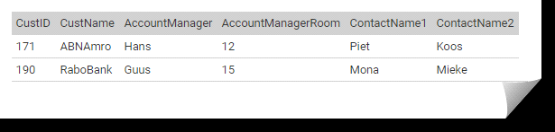

Ans

custId ---> custName

custId ---> AccountManager

custId ---> ContactName1

custId ---> ContactName2

AccountManager ---> AccountManagerRoom

BCNF form

CustomerDetail (CustID, CustName, AccountManager, ContactName1, ContactName2)

ManagerDetail (AccountManager, AccoutManagerRoom)

**2. Draw an ER diagram for a hospital management system.**

Invoice

has

N

Doctor

N

Patient

Treatment

N

1

Medicine

N

**3. Consider a relation Student (StudentID, ModuleID, ModuleName, StudentName, StudentAddress, TutorId, TutorName). Each student is given a StudentID and each module given a ModuleID. A student can register more modules and a module can be registered by more students. TutorID is the ID of the student's personal tutor, it is not related to the modules that the student is taking. Each student has only one tutor, but a tutor can have many tutees. Different students can have the same name. Different students can be living at the same address.**

**Find all the functional dependencies holding in this relation and normalize the table to 3NF**

**given :** Student (StudentID, ModuleID, ModuleName, StudentName, StudentAddress, TutorId, TutorName).

Function Dependencies :

StudentID --> ModuleName

StudentID --> StudentName

StudentID -->StudentAddress

StudentID --> TutorID

ModuleID--> ModuleName

TutorID --> TutorName

3NF form of above table

**Student** (StudentID, StudentName, AddressID, TutorID)

**Addresses**(AddressID, AddressLine1, AddressLine2, City, State, Country)

**Module** (ModuleD, ModuleName)

**ModuleRegistration** (registrationID, StudentID, ModuleID)

**Tutor** (TutorID, TutorName)